Use Case and Design Specification Give Solutions
Project – TEKDESK

Author: Bharath R
Document Number: Use Case and Design Specification Give Solutions V1.0
Document Version Number: Version V1.0 Last Modified: 3rd May 2021

Table of Contents

1. Name 2
1.1 Brief Description 2
1.2 Actor Description 2
1.3 Screen Mockup 2

2 Pre Conditions 3

3. Flow of Events 3
2.1 Basic Flow 3

4. Post Conditions 3
5. Document Change History 4

Use Case Specification- sample

Name
Give Solutions.

Brief Description
This use case describes the scenario when the employee wants to Give Solutions.

Actor Description
Employee or SME who can provide solutions to the query raised by one of the employees in the organization.

Screen Mockup

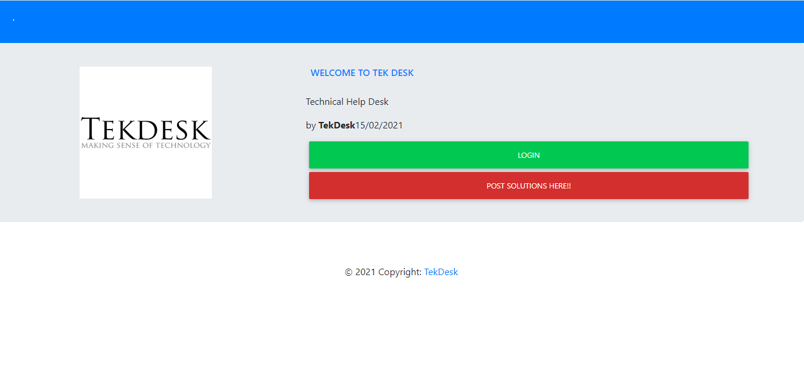

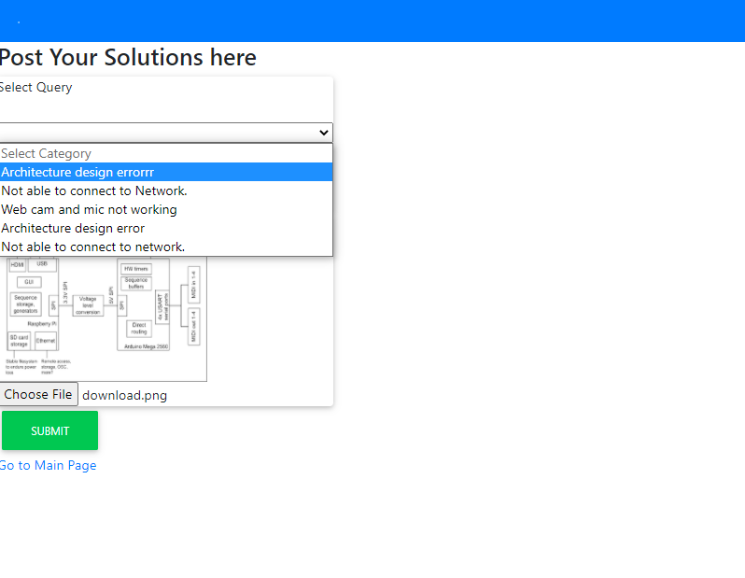

Pre-Conditions
Any employee in the organization has to be raised a query.

Flow of Events

Basic Flow
- The use case begins when the employee or SME wants to give solutions.

- When the employee clicks on Post Solutions Here button the page is navigated to Post Solutions Here Page.

- To provide solutions any one of the categories has to be selected from category drop-down box.

- Employees can also attach files of any format and a preview of it is displayed.

- If the attached file is not enough to solve the query, they can provide additional information the text box area.

Post Conditions
After successful submission of Solution the Status column in the View Query page will be changed from OPEN to CLOSED.

Document Change History

Date | Author/Editor | Description of Change(s)
03/05/2021 | Bharath R | Version 1.0

